

**UniverSity Of SouthAsia   
47-Tufail Road, Lahore Cantt, Pakistan**

FYP Proposal

for

**Goods Transport Management System**  
Version 1.0

***By***

**Nadeem Asghar B-20020**

***Supervisor*Sir Muhammad Kashif**

***Bachelor of Science in Computer Science (2015-2019)***

**Document: Project Proposal Request**

### PROJECT TITLE

* 1. PROJECT NAME: Goods Transport Management System
  2. ADVISER NAME: Sir Muhammad Kashif

### GROUP MEMBERS

* 1. REGISTRATION NUMBER: FYP-19-15-20020
  2. ROLL NO: B-20020
  3. NAME: Nadeem Asghar

(D) SESSION: 2015-2019

(E) EMAIL ID Nadeemasghar476@gmail.com

(F) PHONE: 03014636351

**Project Category: (**Select all the major domains of proposed project**)**

**A-**Web Application ** B-**Android Application

# Introduction

The Goods Transport Management System is the application developed to easily manage the transportation work, keeping the transport agency up-to-date regarding the vehicles information. Goods Transport agency has to transport goods from one city to another city. They have to keep track of each and every truck or other transport vehicles they own in their company. To manage the transportation business, they have to record each and every transport trip of the vehicles.

Goods Transportation Management System is a software application to maintain day to day transactions in transport office. Using this system, user can manage transport work. He can select vehicle to transport the goods, also track the vehicle delivery of goods, can book good transport order online and also check his delivery status of goods online.

# Problem Statement

In existing system, work is done manually. It is very difficult to find old records. Since all work is done manually, it takes time to give report to management regarding their query. To book an order, user has to come to transportation office. User is not able to check his delivery status of goods also. Work is done on paper, so it is prone-to-error system. Sometimes it is very difficult to manage all transport delivery. So the existing manual system needs to be automated.

# Problem Solution for Proposed System

The proposed system will ensure atomization of manually done existing transport system. It will store all the records of goods delivery. Using this system, user can check the rates of transportation and routes to the destination online, can check everything online, can book his order to transport his goods and can also manage billing operation of transportation. Admin can also check the trucks that are available for transportation and how long it takes to reach the delivery point. The proposed system provides the basic components of a shared information system to support the collaboration, rates, routes, roles, transaction sets, documents, and information exchanged to facilitate the booking, execution, and settlement of any type of transportation movement.

# Advantages/Benefits of Proposed System

* It will assure the users 24/7 availability.
* The application will be affordable for general public.
* Monitoring the both of Driver and your books order activities.
* User friendly application.

# Initial Scope

Project Scope

This platform will have an easy approach. This will reduce the time-wasting problems of people. The people will have no need to get any extra software or application or skill to use this application. An un-educated person having no experience of these application may be able to use this application as it will be very much user friendly.

## Project methodology:

**Modal:** Spiral model

**Project Specific Diagram:**

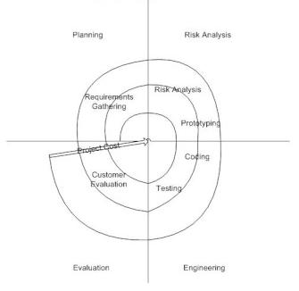

**Reasons:**

1. Project involve a large amount of data which lead to the risk management and better deal in spiral modal.
2. Risk of security is high in this project

**Project Architecture**

It will be an Android native application as the data hosted on the server so the user can connect to the server with an android device with active internet connection.

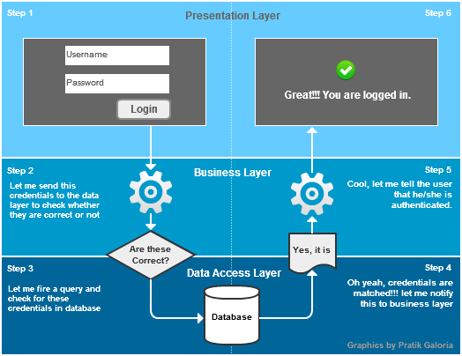

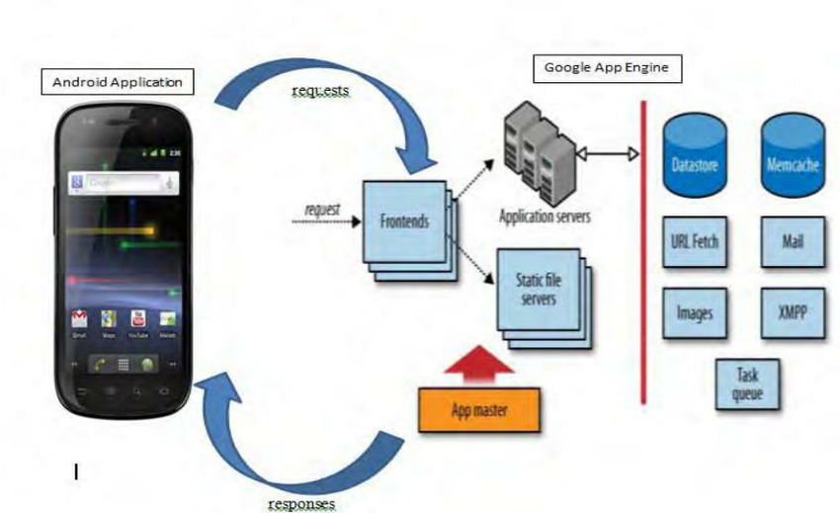

Internet connection

Customer turns on application

Booking a vehicle/ or booking the order

My location is able UI screen available

Driver receive the location and time on that customer

Sending to the current location and date and time to available driver

Customer to receive driver name$ vehicle number

**Project Management Deliverables**

Documentation #1

Analyze the Feasibility, plan the project and create a written document with a flow of the application and create a deployment process.

Prototype #2

A skeleton a product. outline in the form of illustrations or schematics that capture an aspect of design such as an layout, theme and sequence.

Low Fidelity Design #2a

Simple and low-tech concepts. To analyze feedback in the early stages. The goal is to turn your ideas into testable artifacts

Service

Member can participate in the [design process](https://www.invisionapp.com/inside-design/6-ways-speed-improve-product-design-process/) and think through content, menus, and flow. Outcome

Quickly redo part of the design based on comments

High Fidelity Design #2b

Close to the final product, with most of the necessary design assets and components such as splash screen, icons.

service

This allows members to get detailed feedback on certain elements of the design.

outcome

Members will get a clear idea of how the product will look and work before it ever goes live.

Development#3

Develop process and procedures to fulfill the requirement.

XML Template #3a

High fidelity design will transformed into actual device, which will be rendered with backend development.

Services

Design can work with different size orientation devices Outcome

Front end developed to integrate with the backend

Coding #3b

Backend coding will done in this phase to integrate the designed component with the database.

Service

User can now use the components. Outcome

Final product will be developed and ready for testing

Validation and Testing #2c

All the code integrated and deployed in the environment. Testing will done using the firebase testing lab by running on the different devices.

Service

Error and bugs will remove in this phase. Outcome

Final product will be ready for launch.

# Modules

Following are the major modules of “Goods Transports Management System”.:

## Module 1: User Management

### Buyer (Booking Order):

* Create new account.
* Email confirmation via Google, Yahoo etc.
* Phone no Confirmation.

**After Registration**

* Request for new booking Order
* Select books vehicle
* Select your home
* Message to Vehicle Driver
* Option to select the share Booking order List
* Option to select the not share Booking order List
* List down the item of list
* Then the approve the admin
* Seen his history Past books vehicle
* View Bill and payment Procedure
* Cancel the Booking order
* Notification
* Account setting

### Admin

* Login
* Manage whole Platform
* Manage All Vehicle Record
* Manage All Driver Record
* Manage Platform Rule and Standard
* Make New Vehicle
* Make New Driver
* Notifications
* View Top Rated order of the year
* View Top Rated Driver of the year
* Assign User Role
* Account Setting

### Sub-Admin

* Login
* Approved Vehicle and Driver Account
* Approved **Buyer Request**
* View Top Rated Buyers of the year
* View Top Rated Sellers of the year
* Take Action any illegal activity
* Notifications
* Account Setting

## Module 2: Notifications, Messaging, Monitoring and Reporting

* User Log-in, Log-out.
* User Account Management.
* Chat and Messaging to Driver
* New Message Notifications
* 24/7 monitoring via notifications, messages on platform.
* User can report any illegal activity
* User can report when face some problems
* Can show the application installed.
* User can change info.

## Module 3: Payment

* Payment is Generated When your load reach at home or thing to select the place.
* Pay is Payment to Cash.
* Pay is Payment on card.
* When Payment Receive send Confirmation message and email to Driver or Book order.
* Include all Taxes and Tool Plaza.

## Module 4: Update the Schedule

* User goes to the function then Update the Schedule.
  + Books the Vehicle and Select the time and date.

## Module 5 : Driver Detail

* Create new account.
* Email confirmation via Google, Yahoo etc.
* Phone no Confirmation.

**After Registration**

* First of all check the Driver license.
* Then the verification of Driver license.
* Verification Ok then Driver Ok.
* Receive the cash Payment.
* Reporting the Vehicle.
* Reporting the Booking order.
* Receive the Cash Payment.

# System Limitations/Constraints

* This Web Platform access anywhere through internet with any browser.
* For working properly, application need to be installed in the range of GSM and WIFI.

# Tools and Technologies

The tools and technologies that will be used during this project are:

Tools and Technologies for Proposed Project

|  |  |  |  |
| --- | --- | --- | --- |
| **Tools**  **And**  **Technologies** | **Tools** | **Version** | **Rationale** |
| Android Studio | 7.0 | IDE |
| XLM | 7.0 | Front end of Mobile App |
| Lite SQL | 2013 | Data Base |
| Adobe Photoshop | CC 2017 | Design Work |
| MS Word | 2019 | Documentation |
| MS Power Point | 2019 | Presentation |
|
| **Technology** | **Version** | **Rationale** |
| Html CSS3 | 5 | Web Development |
| Bootstrap |  | Design library for Web |
| JavaScript |  | Web Development |
| jQuery |  | Web Development |
| php |  | Web Application |
| SQL |  | Query Language |

# Project Stakeholders and Roles

Project Stakeholders for Proposed Project

|  |  |
| --- | --- |
| **Project Sponsor** | TBD |
| **Stakeholder** | * **Pro: Masroor Hussain University of South Asia.** * Nadeem Asghar * **Supervisor:** TBD * **FYP Committee:** Evaluators of the Project **Supervisor:** * **FYP Committee:** Evaluators of the Project |

# Team Members Individual Tasks

Team Member Work Division for Proposed Project

|  |  |  |
| --- | --- | --- |
| **Student Name** | **Student Registration Number** | **Responsibility/ Modules** |
| Nadeem Asghar | FYP19-15-20020 | **Module # 1**, Module 1.1, Module 1.2, Module 1.3, Module 1.4, Module 2 |

# Data Gathering Approach

Most of the data regarding this project has been gathered with the help of Research and development operating in USA Lahore. Some of it has been gathered from previous study in the respective field.

**Concept-1: Web Development** using **.Larvel**  User and Service Provider Portal will be developed using this technology. The respective technologies are fast in giving solutions/results and will give us great amount of hands-on experience.

**Concept-2: Android Studio** We already have worked in this platform. But working for a final project on it will. We will gain great amount of experience and new features.

**NO PLAGIARISM AND FAIR PLAY DECLARATION**

We the group members of the FYP titled “**Goods Transport Management System**” understand the meaning and implications of the act of plagiarism in academic works and we do solemnly declare and promise not to indulge ourselves directly or indirectly in any acts of plagiarism and/or use or misuse of any work done by other parties, or any activities that are considered miss-appropriate by the project advisers/supervisors and/or considered to be illegal by the regulations of any kind; unless of course permitted by our project adviser/supervisor that is within legal bounds and is/are deemed necessary by them. Our project and product are unique, of quality and are not a reputation or copy of any previous project(s).We declare that we will produce work that is genuine, innovative and reflective of all the study that we had as the students of university of south Asia.

We promise to follow the schedule during which we shall seek feedback and maintain a liaison with our adviser. We understand that any foul-play or infringement on our part will result in the cancellation of our project and possibly other penalties may be imposed upon us.

Our project efforts and the end-product are safe, harmless and helpful to humans and society.

**Signed:**

1. <Nadeem Asghar> <B-20020> <nadeemasghar476@gmail.com> <0301-4636351><2015-19>

Project Adviser Name Sir Muhammad Kashif

Signature: ________________________

Project Coordinator Name: Sir Masroor Hussain HOD CS Name Sir Shahid Waseem

Signature: ________________________ Signature: ________________________